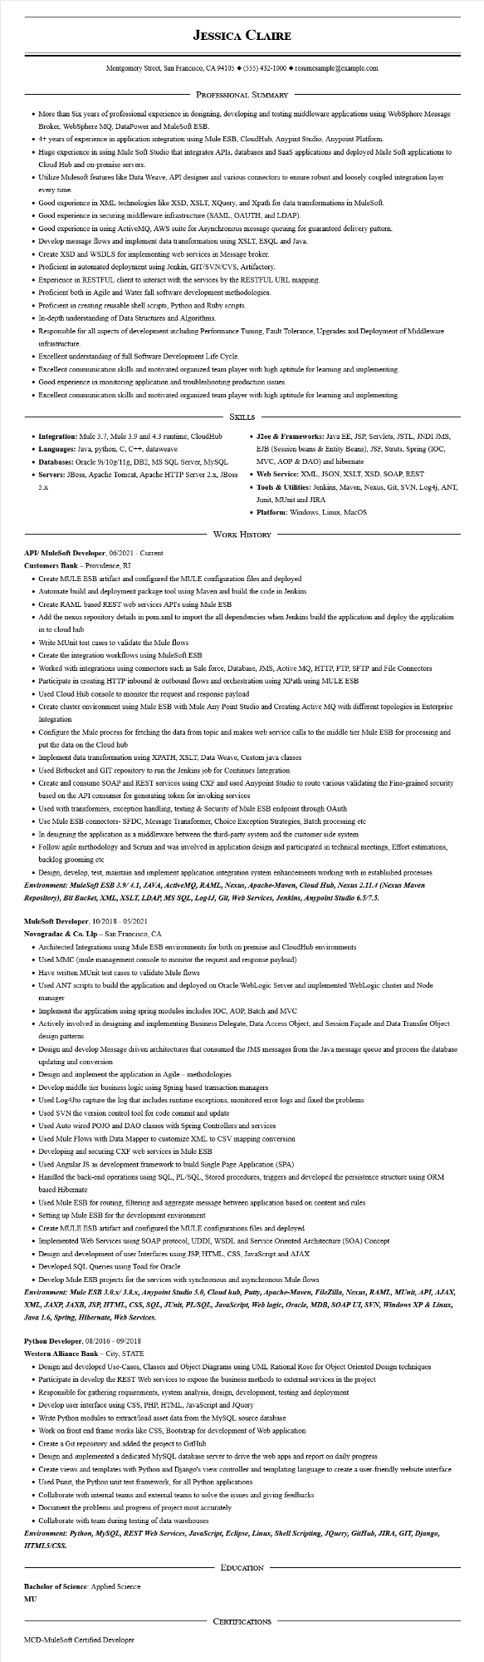
JESSICA CLAIRE
Montgomery Street, San Francisco, CA 94105 ♦ (555) 432-1000 resumesample@example.com
PROFESSIONAL SUMMARY
• More than Six years of professional experience in designing, developing and testing middleware applications using WebSphere Message Broker, WebSphere MQ, DataPower and MuleSoft ESB.
• 4+ years of experience in application integration using Mule ESB, CloudHub, Anypint Studio, Anypoint Platform.
• Huge experience in using Mule Soft Studio that integrates APIs, databases and SaaS applications and deployed Mule Soft applications to Cloud Hub and on-premise servers.
• Utilize Mulesoft features like Data Weave, API designer and various connectors to ensure robust and loosely coupled integration layer every time.
• Good experience in XML technologies like XSD, XSLT, XQuery, and Xpath for data transformations in MuleSoft.
• Good experience in securing middleware infrastructure (SAML, OAUTH, and LDAP).
• Good experience in using ActiveMQ, AWS suite for Asynchronous message queuing for guaranteed delivery pattern.
• Develop message flows and implement data transformation using XSLT, ESQL and Java.
• Create XSD and WSDLS for implementing web services in Message broker.
• Proficient in automated deployment using Jenkin, GIT/SVN/CVS, Artifactory.
• Experience in RESTFUL client to interact with the services by the RESTFUL URL mapping.
• Proficient both in Agile and Water fall software development methodologies.
• Proficient in creating reusable shell scripts, Python and Ruby scripts.
• In-depth understanding of Data Structures and Algorithms.
• Responsible for all aspects of development including Performance Tuning, Fault Tolerance, Upgrades and Deployment of Middleware infrastructure.
• Excellent understanding of full Software Development Life Cycle.
• Excellent communication skills and motivated organized team player with high aptitude for learning and implementing.
• Good experience in monitoring application and troubleshooting production issues.
• Excellent communication skills and motivated organized team player with high aptitude for learning and implementing.
• Integration: Mule 3.7, Mule 3.9 and 4.3 runtime, CloudHub
• Languages: Java, python, C, C++, dataweave
• Databases: Oracle 9i/10g/11g, DB2, MS SQL Server, MySQL
SKILLS
• Servers: JBoss, Apache Tomcat, Apache HTTP Server 2.x, JBoss 5.x
• J2ee & Frameworks: Java EE, JSP, Servlets, JSTL, JNDI JMS, EJB (Session beans & Entity Beans), JSF, Struts, Spring (IOC, MVC, AOP & DAO) and hibernate
• Web Service: XML, JSON, XSLT, XSD, SOAP, REST
• Tools & Utilities: Jenkins, Maven, Nexus, Git, SVN, Log4j, ANT, Junit, MUnit and JIRA
• Platform: Windows, Linux, MacOS
WORK HISTORY
API/ MuleSoft Developer, 06/2021 - Current
Customers Bank - Providence, RI
• Create MULE ESB artifact and configured the MULE configuration files and deployed
• Automate build and deployment package tool using Maven and build the code in Jenkins
• Create RAML based REST web services API's using Mule ESB
• Add the nexus repository details in pom.xml to import the all dependencies when Jenkins build the application and deploy the application in to cloud hub
• Write MUnit test cases to validate the Mule flows
• Create the integration workflows using MuleSoft ESB
• Worked with integrations using connectors such as Sale force, Database, JMS, Active MQ, HTTP, FTP, SFTP and File Connectors
• Participate in creating HTTP inbound & outbound flows and orchestration using XPath using MULE ESB
• Used Cloud Hub console to monitor the request and response payload
• Create cluster environment using Mule ESB with Mule Any Point Studio and Creating Active MQ with different topologies in Enterprise Integration
• Configure the Mule process for fetching the data from topic and makes web service calls to the middle tier Mule ESB for processing and put the data on the Cloud hub
• Implement data transformation using XPATH, XSLT, Data Weave, Custom java classes
• Used Bitbucket and GIT repository to run the Jenkins job for Continues Integration
• Create and consume SOAP and REST services using CXF and used Anypoint Studio to route various validating the Fine-grained security based on the API consumer for generating token for invoking services
• Used with transformers, exception handling, testing & Security of Mule ESB endpoint through OAuth
• Use Mule ESB connectors- SFDC, Message Transformer, Choice Exception Strategies, Batch processing etc
• In designing the application as a middleware between the third-party system and the customer side system
• Follow agile methodology and Scrum and was involved in application design and participated in technical meetings, Effort estimations, backlog grooming etc
• Design, develop, test, maintain and implement application integration system enhancements working with in established processes Environment: MuleSoft ESB 3.9/4.1, JAVA, ActiveMQ, RAML, Nexus, Apache-Maven, Cloud Hub, Nexus 2.11.4 (Nexus Maven Repository), Bit Bucket, XML, XSLT, LDAP, MS SQL, Log4J, Git, Web Services, Jenkins, Anypoint Studio 6.5/7.5.
MuleSoft Developer, 10/2018 - 05/2021
Novogradac & Co. Llp - San Francisco, CA
• Architected Integrations using Mule ESB environments for both on premise and CloudHub environments
• Used MMC (mule management console to monitor the request and response payload)
• Have written MUnit test cases to validate Mule flows
• Used ANT scripts to build the application and deployed on Oracle WebLogic Server and implemented WebLogic cluster and Node manager
• Implement the application using spring modules includes IOC, AOP, Batch and MVC
• Actively involved in designing and implementing Business Delegate, Data Access Object, and Session Façade and Data Transfer Object design patterns
• Design and develop Message driven architectures that consumed the JMS messages from the Java message queue and process the database updating and conversion
• Design and implement the application in Agile - methodologies
• Develop middle tier business logic using Spring based transaction managers
• Used Log4Jto capture the log that includes runtime exceptions, monitored error logs and fixed the problems
• Used SVN the version control tool for code commit and update
• Used Auto wired POJO and DAO classes with Spring Controllers and services
• Used Mule Flows with Data Mapper to customize XML to CSV mapping conversion
• Developing and securing CXF web services in Mule ESB
• Used Angular JS as development framework to build Single Page Application (SPA)
• Handled the back-end operations using SQL, PL/SQL, Stored procedures, triggers and developed the persistence structure using ORM based Hibernate
• Used Mule ESB for routing, filtering and aggregate message between application based on content and rules
• Setting up Mule ESB for the development environment
• Create MULE ESB artifact and configured the MULE configurations files and deployed
• Implemented Web Services using SOAP protocol, UDDI, WSDL and Service Oriented Architecture (SOA) Concept
• Design and development of user Interfaces using JSP, HTML, CSS, JavaScript and AJAX
• Developed SQL Queries using Toad for Oracle
• Develop Mule ESB projects for the services with synchronous and asynchronous Mule flows
Environment: Mule ESB 3.0.x/3.8.x, Anypoint Studio 5.0, Cloud hub, Putty, Apache-Maven, FileZilla, Nexus, RAML, MUnit, API, AJAX, XML, JAXP, JAXB, JSP, HTML, CSS, SQL, JUnit, PL/SQL, JavaScript, Web logic, Oracle, MDB, SOAP UI, SVN, Windows XP & Linux, Java 1.6, Spring, Hibernate, Web Services.
Python Developer, 08/2016 - 09/2018
Western Alliance Bank - City, STATE
• Design and developed Use-Cases, Classes and Object Diagrams using UML Rational Rose for Object Oriented Design techniques
• Participate in develop the REST Web services to expose the business methods to external services in the project
• Responsible for gathering requirements, system analysis, design, development, testing and deployment
• Develop user interface using CSS, PHP, HTML, JavaScript and JQuery
• Write Python modules to extract/load asset data from the MySQL source database
• Work on front end frame works like CSS, Bootstrap for development of Web application
• Create a Git repository and added the project to GitHub
• Design and implemented a dedicated MySQL database server to drive the web apps and report on daily progress
• Create views and templates with Python and Django's view controller and templating language to create a user-friendly website interface
• Used Punit, the Python unit test framework, for all Python applications
• Collaborate with internal teams and external teams to solve the issues and giving feedbacks
• Document the problems and progress of project most accurately
• Collaborate with team during testing of data warehouses
Environment: Python, MySQL, REST Web Services, JavaScript, Eclipse, Linux, Shell Scripting, JQuery, GitHub, JIRA, GIT, Django, HTML5/CSS.
Bachelor of Science: Applied Science
MU
MCD-MuleSoft Certified Developer
EDUCATION
CERTIFICATIONS

